Create a React Application named “cricketapp” with the following components:

1. **ListofPlayers:**

import React from "react";

const players = [

  { name: "Virat", score: 85 },

  { name: "Rohit", score: 60 },

  { name: "Rahul", score: 45 },

  { name: "Hardik", score: 90 },

  { name: "Jadeja", score: 72 },

  { name: "Shami", score: 40 },

  { name: "Bumrah", score: 95 },

  { name: "Gill", score: 68 },

  { name: "Surya", score: 82 },

  { name: "Ishan", score: 35 },

  { name: "Kuldeep", score: 78 },

];

const ListofPlayers = () => {

  const below70 = players.filter((player) => player.score <= 70);

  return (

    <div>

      <h2>All Players</h2>

      <ul>

        {players.map((player) => (

          <li key={player.name}>

            {player.name} - {player.score}

          </li>

        ))}

      </ul>

      <h2>Players Scoring Below 70</h2>

      <ul>

        {below70.map((player) => (

          <li key={player.name}>

            {player.name} - {player.score}

          </li>

        ))}

      </ul>

    </div>

  );

};

export default ListofPlayers;

1. **IndianPlayers:**

import React from "react";

const OddTeam = ["Sachin1", "Dhoni2", "Virat3", "Rohit4", "Yuvaraj5", "Raina6"];

const T20Players = ["First Player", "Second Player", "Third Player"];

const RanjiTrophyPlayers = ["Fourth Player", "Fifth Player", "Sixth Player"];

export const IndianPlayers = [...T20Players, ...RanjiTrophyPlayers];

export const fullOddTeam = OddTeam;

export const OddPlayers = ({ team }) => {

  const [first, , third, , fifth] = team;

  return (

    <div>

      <h2>Odd Players</h2>

      <ul>

        <li>First: {first}</li>

        <li>Third: {third}</li>

        <li>Fifth: {fifth}</li>

      </ul>

    </div>

  );

}

export const EvenPlayers = ({ team }) => {

  const [, second, , fourth, , sixth] = team;

  return (

    <div>

      <h2>Even Players</h2>

      <ul>

        <li>Second: {second}</li>

        <li>Fourth: {fourth}</li>

        <li>Sixth: {sixth}</li>

      </ul>

    </div>

  );

};

**App.jsx:**

import React from "react";

import ListofPlayers from "./components/ListofPlayers";

import {

  IndianPlayers,

  OddPlayers,

  EvenPlayers,

  fullOddTeam,

} from "./components/IndianPlayers";

const App = () => {

  const flag = false; // toggle between true/false

  return (

    <div>

      <h1>🏏 Welcome to Cricket App</h1>

      {flag ? (

        <ListofPlayers />

      ) : (

        <>

          <OddPlayers team={fullOddTeam} />

          <EvenPlayers team={fullOddTeam} />

          <h2>List of Indian Players Merged:</h2>

          <ul>

            {IndianPlayers.map((player, index) => (

              <li key={index}>Mr. {player}</li>

            ))}

          </ul>

        </>

      )}

    </div>

  );

};

export default App;

**Output:**

When Flag=true

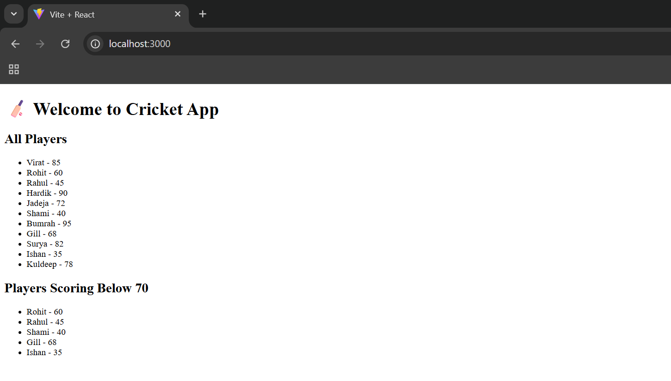

When Flag=false

